# Measurable and Progress from maladaptive behaviors.

|  |  |  |  |  |  |
| --- | --- | --- | --- | --- | --- |
| Maladaptive Behaviors | Baseline Date:2017-08-28to2017-08-30 | Current average per week (3/31/2020) | % of Reduction(BL-average/ BL)*100 | Status | Updated STO (3/31/2020) |
| Tantrum | 28 incidents per weeks | 10 incidents per week. | 63% | In progress | Sto1(MASTERED 2018-01-06). Sto2(MASTERED 2018-10-27). Sto3(MASTERED 2019-04-11). Currently: STO 4(Initiated 5/1/2019) |
| Self-Injurious behavior | 21 incidents per weeks | 3 incidents per week. | 86% | LTO in progress | Sto1(MASTERED 2018-01-20). Sto2(MASTERED 2018-10-13). Sto3(MASTERED 2019-03-08). Sto4(MASTERED 2019-08-09). |
| Property destruction | 35 incidents per weeks | 6 incidents per week. | 82% | In progress | Sto1(MASTERED 2018-01-13). Sto2(MASTERED 2018-10-20). Sto3(MASTERED 2019-08-09). Currently: STO 4(Initiated 9/1/2019) |
| Physical Aggression | 21 incidents per weeks | 2 incidents per week. | 89% | In progress | Sto1(MASTERED 2018-01-20). Sto2(MASTERED 2018-10-20). Sto3(MASTERED 2019-03-08). Currently: STO 4(Initiated 4/1/2019) |
| Task Refusal | 21 incidents per weeks | 6 incidents per week. | 71% | In progress | Sto1(MASTERED 2018-02-03). Sto2(MASTERED 2018-10-27). Currently: STO 3(Initiated 11/1/2018) |
| Disruption | 42 incidents per weeks | 20 incidents per week. | 51% | In progress | Sto1(MASTERED 2019-01-19). Sto2(MASTERED 2019-06-15). Sto3(MASTERED 2019-10-26). Currently: STO 4(Initiated 11/1/2019) |
| Mouthing | 35 incidents per weeks | 14 incidents per week. | 59% | In progress | Sto1(MASTERED 2019-04-18). Sto2(MASTERED 2019-09-21). Sto3(MASTERED 2020-03-27). Currently: STO 4(Initiated 4/1/2020) |
| Total of Reduction (%) | - | - | - | - | 72.1343537415 |

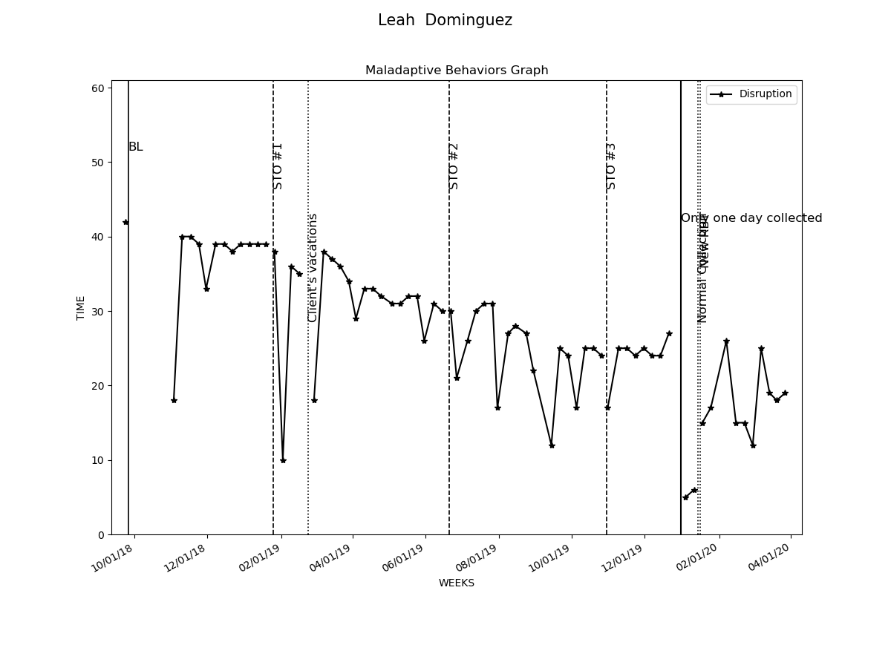

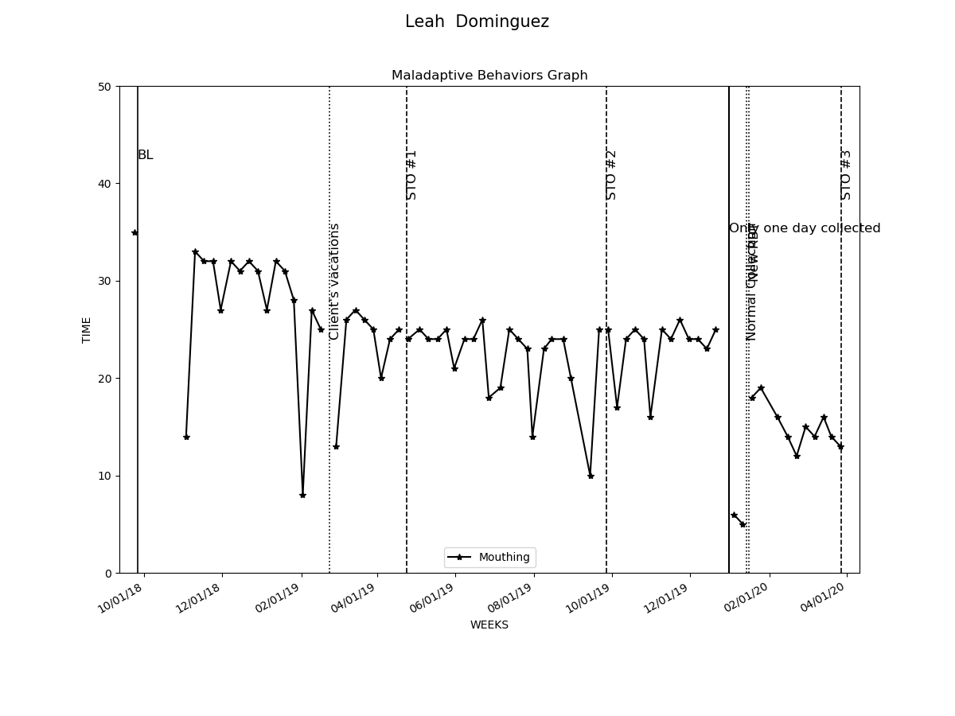

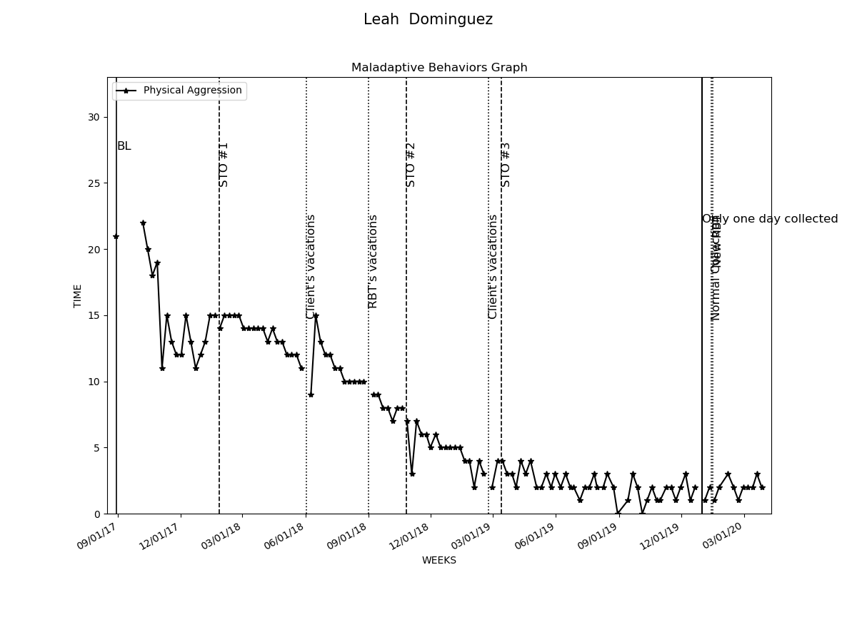

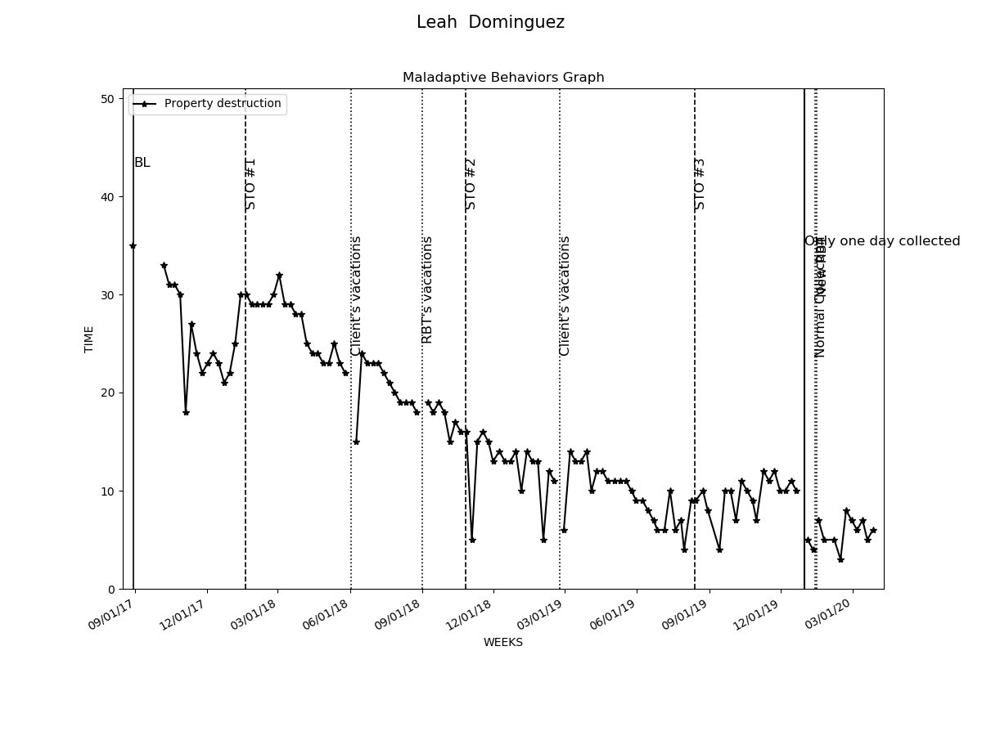

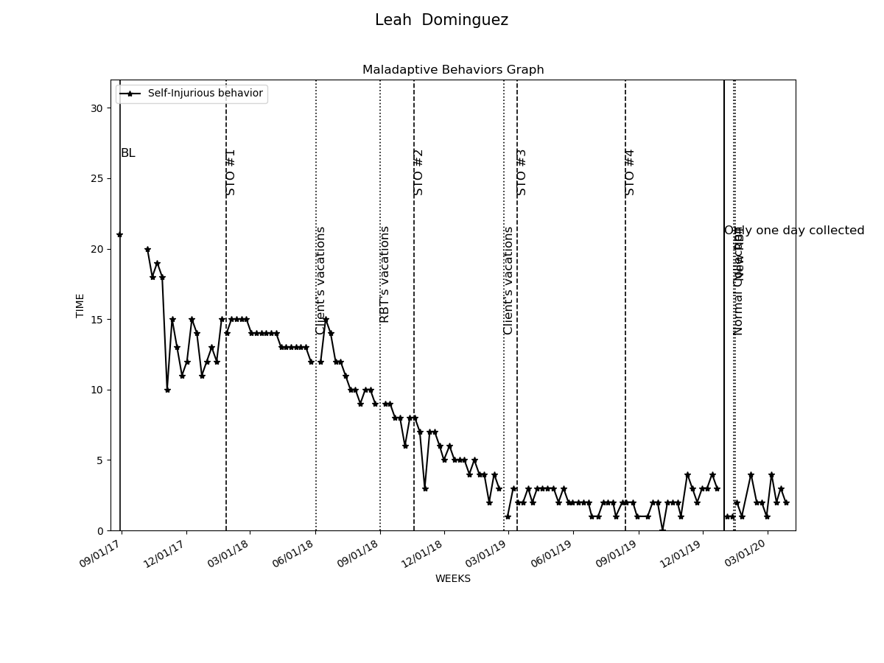

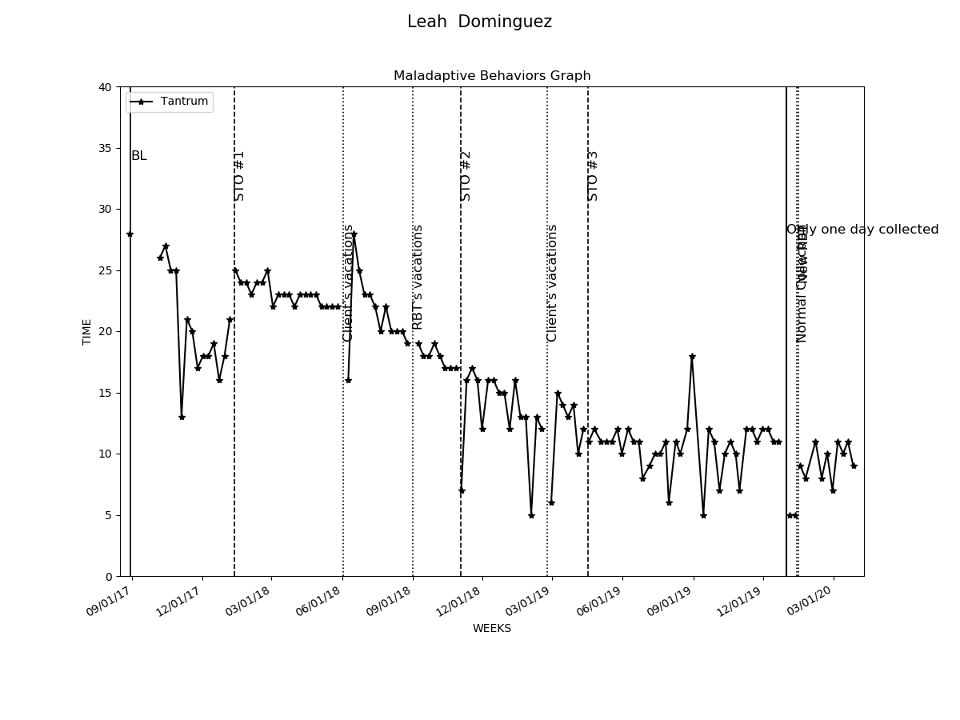

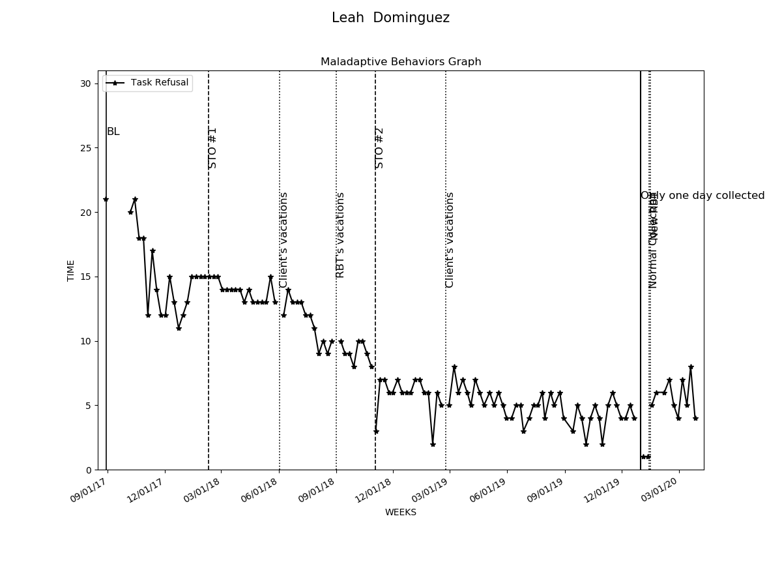

# Graphs Replacement and Interventions

|  |  |  |  |  |
| --- | --- | --- | --- | --- |
| Replacements and Programs | Baseline Date:2017-11-04to2017-11-07 | Current average per week (3/31/2020) | Status | Updated STO (3/31/2020) |
| 1- Request Break | 7% | 67% | In progress | Sto1(MASTERED 2018-03-17). Sto2(MASTERED 2018-12-22). Sto3(MASTERED 2019-07-31). Currently: STO 4(Initiated 8/1/2019) |
| 2- Request Attention | 7% | 66% | In progress | Sto1(MASTERED 2018-03-17). Sto2(MASTERED 2018-12-22). Sto3(MASTERED 2019-08-15). Currently: STO 4(Initiated 9/1/2019) |
| 3- Request Tangible | 7% | 66% | In progress | Sto1(MASTERED 2018-03-17). Sto2(MASTERED 2018-12-22). Sto3(MASTERED 2019-08-15). Currently: STO 4(Initiated 9/1/2019) |
| 4- Follow instructions | 7% | 63% | In progress | Sto1(MASTERED 2018-03-17). Sto2(MASTERED 2018-12-22). Sto3(MASTERED 2019-07-13). Currently: STO 4(Initiated 8/1/2019) |
| 5- Wait for Tangible | 7% | 68% | In progress | Sto1(MASTERED 2018-03-17). Sto2(MASTERED 2019-01-19). Sto3(MASTERED 2019-08-15). Currently: STO 4(Initiated 9/1/2019) |
| 6- Social Skills- Interrupt conversation politely | 7% | 48% | In progress | Sto1(MASTERED 2018-03-17). Sto2(MASTERED 2019-04-04). Currently: STO 3(Initiated 5/1/2019) |
| 7- Compliance with activity schedule - Toilet schedule | 3% | 67% | In progress | Sto1(MASTERED 2018-03-17). Sto2(MASTERED 2018-10-20). Sto3(MASTERED 2019-05-25). Currently: STO 4(Initiated 6/1/2019) |
| 8- Compliance with activity schedule - Put pullover shirt on and off | 7% | 64% | In progress | Sto1(MASTERED 2018-03-17). Sto2(MASTERED 2018-10-20). Sto3(MASTERED 2019-05-25). Currently: STO 4(Initiated 6/1/2019) |
| 9- Compliance with activity schedule - Remain seated | 7% | 85% | In progress | Sto1(MASTERED 2018-03-17). Currently: STO 2(Initiated 4/1/2018) |
| 10- Compliance with activity schedule - Fine Motor skills | 7% | 70% | In progress | Sto1(MASTERED 2018-03-17). Sto2(MASTERED 2018-11-24). Sto3(MASTERED 2019-04-25). Currently: STO 4(Initiated 5/1/2019) |
| 11- Compliance with activity schedule - Brush her teeth | 7% | 69% | In progress | Sto1(MASTERED 2018-03-17). Sto2(MASTERED 2018-10-27). Sto3(MASTERED 2019-04-25). Currently: STO 4(Initiated 5/1/2019) |
| 12- Compliance with activity schedule - Working independently | 20% | 83% | In progress | Sto1(MASTERED 2018-03-24). Currently: STO 2(Initiated 4/1/2018) |
| 16- Social Skills- Sharing toys | 13% | 37% | In progress | Sto1(MASTERED 2019-05-25). Currently: STO 2(Initiated 6/1/2019) |
| 17- Night Time Routine | 13% | 29% | In progress | Sto1(MASTERED 2019-05-04). Currently: STO 2(Initiated 6/1/2019) |
| 18- Sensory enrichment activities | 13% | 29% | In progress | Sto1(MASTERED 2019-04-11). Currently: STO 2(Initiated 5/1/2019) |
| 19- Parent Training-Data collection of Maladaptive Behaviors | 5% | 39% | In progress | Sto1(MASTERED 2019-12-07). Currently: STO 2(Initiated 1/1/2020) |
| 20- Parent Training-Generalization of Skills | 0% | 41% | In progress | Sto1(MASTERED 2019-12-07). Currently: STO 2(Initiated 1/1/2020) |

